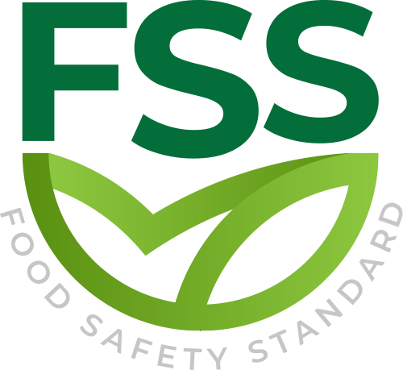

DEFINITIONS STANDARD

Document Code _ FSS-STD-001
Approval Date : 20.02.2020

Title: Food Safety Standard (FSS)
Contact Adress : Merkez Mahallesi Dr Sadık Ahmet Cd, No 38/44 A Bağcılar/İstanbul – Türkiye / Turkey
Contact Mail: info@foodcertificate.org
Website: www.foodcertificate.org
Phone: +90 212 702 40 00

ABOUT US
The Food Safety System (FSS) certification program developed by our organization is a system for the inspection and evaluation of food safety and quality according to accepted standards. The certification program in question not only ensures food safety, but also undertakes responsibilities such as public health and environmental protection. This certification program is recognized as the most important initiative of recent years for a more effective and quality food management.

While developing the Food Safety System (FSS) certification program, our organization followed a global food safety strategy and adopted a safer food policy to be healthier. According to this strategy, preventing foodborne diseases and ensuring food safety require holistic, risk-based and timely food safety policies and strategies.

Our organization continuously improves its effectiveness by participating in the efforts for the development and implementation of the food management system in enterprises. It supports businesses in the food industry to meet legal and regulatory requirements, tries to establish a quality policy in businesses, supports businesses in establishing food safety targets, directs management reviews and tries to ensure the correct and effective availability of resources. In all these works, our organization approaches businesses in an impartial and independent manner and does not enter into any conflict of interest.

Our organization acts with a sense of responsibility in order to be with people who care about their nutrition and to help them make safe food choices. In this context, it provides Food Safety System (FSS) certification services to support companies that produce, store, distribute and prepare food in order to prove their efforts in this direction.

- Audıtor
The person conducting the audit.
- Certification
Licensed certification bodies provide procedures to ensure that the food safety and/or quality management system and the audited organization implement compliance with the program requirements.
- Certification Body
Organizations that provide audit and certification services.(ISO 17021-1)
- Certification Decision Date
The date the certification decision was made.
- Certification Decision
The certification body grants, continues, expands or reduces the scope, suspends, resumes, revokes or rejects certification
- Certification Plan
Conformity assessment system related to a management system that applies the same regulatory requirements, specific rules and procedures.(ISO 17021-1)
- Certificate Hanger
The certificate status is declared as temporarily invalid.
- CERTIFICATE WITHDRAWAL
The certificate is finally deactivated according to the certification decision.
- Cleaning Schedule
A plan to remove soil, food, dirt, grease, or other foreign substances to ensure that processing equipment and the environment are kept in hygienic conditions. Methods of application include but are not limited to sanitation and disinfection.
- Complaint
Express dissatisfaction with the organization, related to its products or services, or the complaint handling process itself, in which a response or solution is explicitly or implicitly expected.(ISO 9001)

- Competence
The ability to apply knowledge and skills to achieve expected results.
- Major Nonconformıty
A situation where the system fails and directly affects food safety and the organization does not take appropriate action, or when the legality and/or certification integrity is threatened.
- Cross Docking
The process of unloading, sorting, combining, loading and transporting goods (food, feed, animal food and packaging) to the next destination.
- Breed
Any single or multiple products intended to feed food animals, whether processed, semi-processed or raw.
- Environmental Monitoring
A procedure for evaluating the effectiveness of control measures to prevent pollution in the manufacturing environment.
- Food
Processed, semi-processed or unprocessed product substances (ingredients) for consumption, including beverages, chewing gum, and any substances used in the manufacture, preparation or processing of "food", but excluding cosmetics or tobacco or substances used as medicines .(ISO 22000)
- Food Defending
The process of ensuring the safety of food and beverages from all forms of deliberate malicious attacks, including ideological attacks that lead to contaminated or unsafe products.
- Food Safety Management System
A set of interrelated or interacting elements that are used to formulate policies and goals and achieve these goals, and are used to guide and control the organization's food safety

- FSS LOGO
The logo issued by the foundation can be used by licensed certification agencies, certification organizations, and licensed training organizations in accordance with the requirements of the FSS program.
- Review Audit
Additional audits of regular audits require additional visits when the audit cannot be completed within the planned time and/or the audit plan cannot be fully realized.
- Minor Nonconformity
Non-conformance that does not affect the ability to realize the management system. Expected result
- Manufacturing
Transform raw materials into final products through physical, microbiological or chemical methods.
- Haccp
Hazard analysis of a series of products/services with similar hazards and similar production technologies and (if relevant) similar storage Technologies.
- Organization
A legal entity that has its own functions, responsibilities, authorities, and relationships to meet the requirements of the program and may cover multiple locations.
- Product
The output as a result of the process. Products can be services.Even if handled correctly in the entire supply chain, products of quality and value will be lost within a specified time, so the temperature needs to be controlled during storage and/or transportation to prevent damage, deterioration, and contamination.
- Pet Food
Animal food intended to feed non-food animals, limited to dogs and cats. Animal food intended to be fed to non-edible animals other than dogs and cats.

- Portal
The main digital platform provided by the foundation supports key program processes and data exchange needs​​.
- Process
A set of interrelated or interacting activities that transform input into output.
- Wıtnessed Audit
During the audit, competent supervisors called witnesses regularly observe the auditor's performance.
- Unannounced Audit
An audit conducted in a facility of a certified organization without prior notification of the audit date.
- Scope
Applicable scope and boundaries of audit, certification, accreditation or program activities.
- Special Audits
An audit performed on or outside of the annual surveillance/recertification audit conducted by a certified organization.
- Risk
Effect of uncertainty
- Audit
A systematic, independent, and documented process used to obtain evidence and objectively evaluate it to determine the extent to which the requirements of a particular program are met.
- Accreditation Mark
A mark issued by an accredited body for use by an accredited CB to show direct compliance a set of requirements for an entity.

- Accreditation
Third-party certification related to the certification body, formally certifying its ability to perform specific conformity assessment tasks.(ISO 17011)
- Accreditation Body
Authoritative organization performing certification.
- Accreditatiom Certificate
A formal document or set of documents stating that recognition has been granted for the defined scope.

